**Big 5** [just one tiny word change]

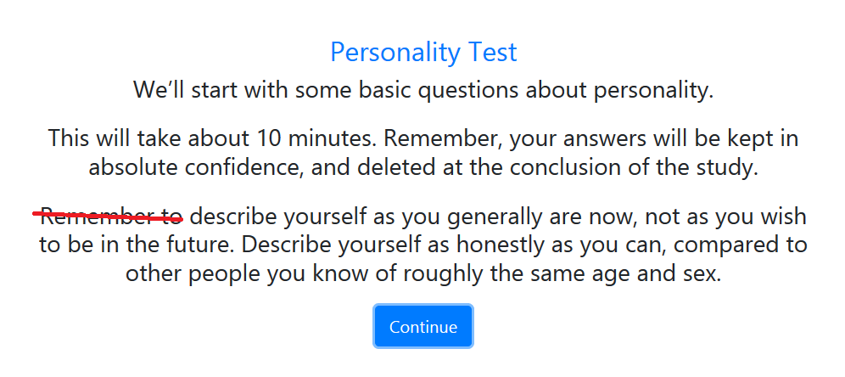

**Memory [couldn’t spot this – so you may well have done the below changes already]**

### FACES

### We give people 20 seconds to remember faces. Could we have a little timer in the top right of the screen?

### Similarly, it would be great to add a timer to the “memory refresher page” where we give people 10 seconds to remember stuff…

### WORDS

### There’s a two second pause (with a white screen) after the “yellow”, “blue”, “red” practice words appear. Bug?

### Small wording change:

### 

### STORY

### In the practice, the story only appears for a couple of seconds. Let’s give people 15 seconds, with a “NEXT” button for them to hit.

### Delete some text:

### 

### The timer on the story page (e.g. where we describe Anna Thompson) is great, but the page vanishes after 2 seconds.

### At the end, can we really emphasise where people did best. Below is probably too over the top, but you get the general idea 😊

### 

### Cryptography

### Individual Version of the Task

### Something weird happened in the practice phase (see below). I’m guessing that maybe the practice doesn’t follow the example mapping?

### 

### Shapes Task

### Remove the bit at the end where we tell people their score!

### Optimization Task

### Individual task

### 

### Note: at the end of the task, can we say “the actual best answer is X, which is typically associated with an output of Y”.

### We want people to do the optimization task TWICE

### Another function:

$$f\left(x\right)=40\sin\left(\frac{x}{15}\right)+100\cos\left(\frac{x}{60}\right)+\frac{x}{5}$$

### 

### Just give the answers in whole numbers (decimals are probably too much)

### Practice round

### “Let’s start with a quick practice.

### Say the number that maximises the output [which you will not know in the test] is 150. Values near 150 return a big positive number. Values near 0 and 300 return negative numbers.

### Practice: enter a number between 0 and 300…

### “Now, let’s do the real thing. Remember, you get 6 guesses. Good luck!”

### Group Cryptography Task [NOT A PRIORITY FOR THIS WEEK]

### Can we have this as an independent task? [i.e. we want people to be able to do the Group Cryptography without having to do the Individual version]

### On the first page, can we have the following instructions:

### ‘Cryptography’ Task [heading in bold] This is exactly the same as the ‘cryptography task’ you individually when you first came to the lab. Now, you will do this task *as a group.*

### You will just use one laptop for this task. Decide now which computer you will use, and click “Group Sign In” on that laptop. Feel free to close the other laptops, as you won’t be needing them until after the break. Note to Gabe: I’m going to make the Cryptography task the last task that a group does.

### Text

### Get rid of “This is a group task” at the start of the Cryptography Group Task.

### After people have hit “Group Sign In” the first paragraph should read:

### “As a reminder, the letters A-J have been randomly mapped to the numbers 0-9. The goal for your group is to decipher this mapping in the minimum number of "trials". You have 10 minutes, and 12 trials to find out which letter corresponds to each number”.

### Remember that a trial involves three steps:

### Propose an EQUATION: the group nominates the left-hand side of an equation, using letters, addition and subtraction: e.g. "A+B". The group then receives an answer, e.g. "A+B=EC"

### Propose a HYPOTHESIS: the group makes a guess as to one element of the mapping, e.g. "E=1". The group then gets confirmation about whether their guess is correct: e.g. "E=1 is TRUE"

### GUESS FULL MAPPING: at the end of each trial, the group guesses at the whole mapping. If you are correct, the task is complete. Otherwise a new trial begins. The group will have 0 trials to complete the task.

### Next page

### “Take a minute to discuss your strategy. Click continue when you’re ready to start the 10 minutes. Remember that there’s a clock in the top right corner that tells you how long you have left”

### Group Optimisation Task [not a priority this week]

### New text for the introduction page

### Group Optimization Task

### Now, we will do the optimization task as a group. Recall that the goal of this task is to try to find the number (between 0 and 300) that results in your computer returning the biggest possible value.

### *EACH MEMBER OF THE GROUP* will have [3] guesses, which you enter into your own laptop. A guess can be any number between [0] and [300].

### After you enter your guess, the computer will give you back a number.

### There is a systematic relationship between the number you guess, and the number you receive, but the relationship will be hard to understand. Every time you type in the same number, the number you receive will be similar (but there is some randomness).

### After everyone in your group has used their [3] guesses, the group needs to decide on a single best answer.

### ONE person needs to click “group sign in” and enter your answer.

### NB: ultimately, we will have groups do 3 optimizations.

### Need a page of instructions after “this is a group task”!